VirtualBox

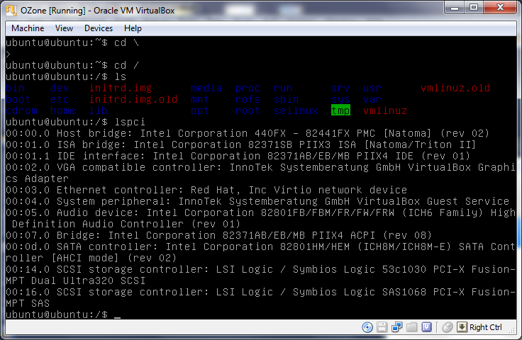

VMWare Player

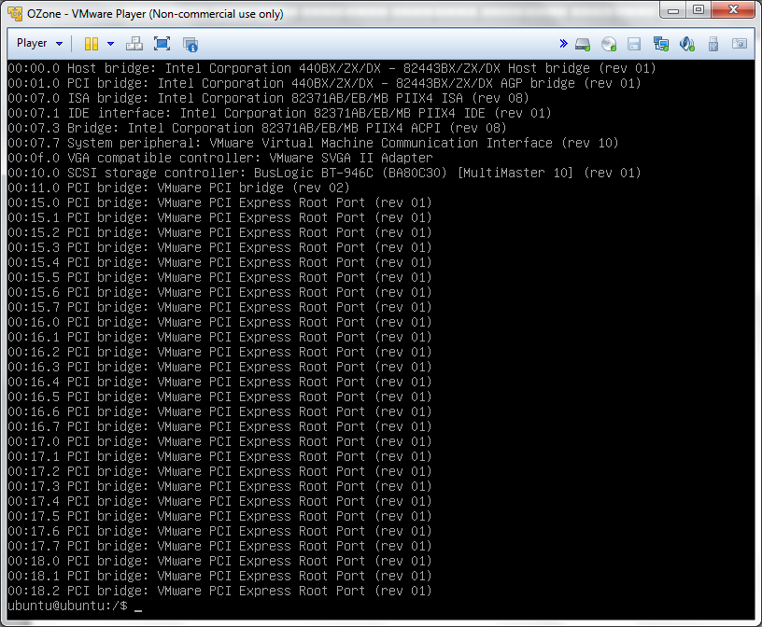

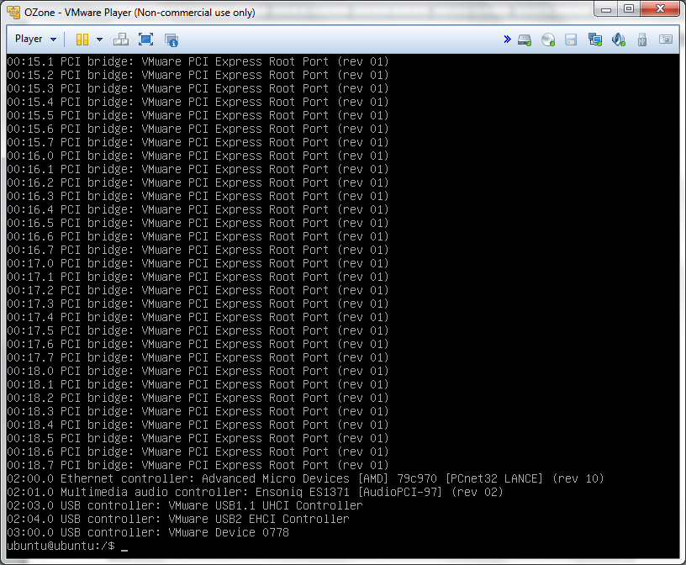

Windows 7 VirtualPC

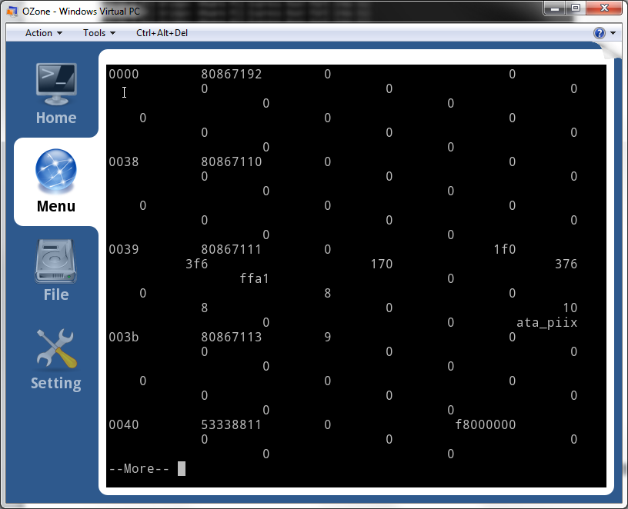

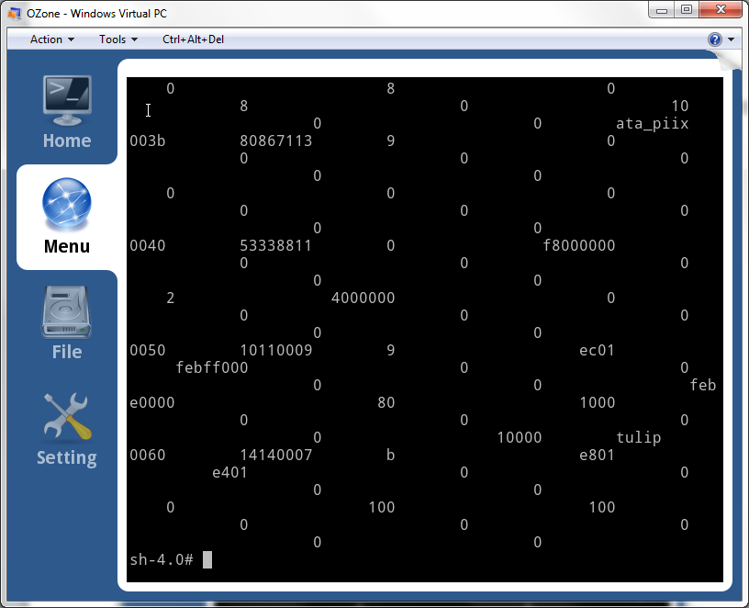

S3 Trio 64/64V  
DC21140 DEC Fast Ethernet Controller (Lan Card10/100 PCI)  
Microsoft Virtual Machine Audio Device (Microsoft(R) PCI Adapter MN-130) (Microsoft / C-Media Inc.)

